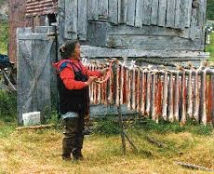

Diabetes Education Basics  
  
A Course for Health Aides

Supporting a Person with Diabetes to Live Healthy in Their Community

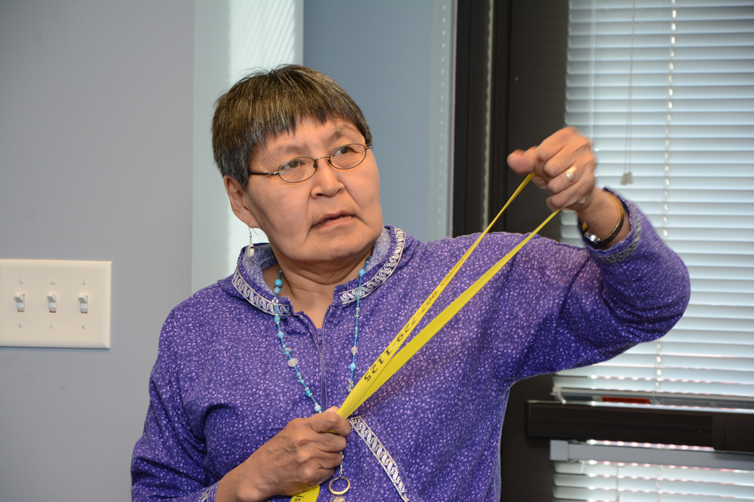

ANTHC Diabetes Program

7 one- hour classes from 9:00am-10:00am

Tuesdays and Thursdays

September 8, 13, 15, 20, 22, 27 and 29

Virtual Class

7 CMEs

Course Description

• An interactive, hands-on VIRTUAL course for CHA/Ps that focuses on teaching diabetes education to people with diabetes who live in rural Alaska.

• This course consists of 7 interactive virtual 1 hour classes, and a pre and post evaluation.

• Content includes: What is diabetes?, blood glucose monitoring, ABCs or diabetes, nutrition and diabetes, physical activity and diabetes, diabetes self-management education, reducing risks of complications, diabetes medications, stress management, coping, problem solving with diabetes and more!

* Health aides accepted into the class will be mailed a box of supplies they will use to participate in hands on activities they will use in the 2nd-7th classes.

• This class is eligible for 7 CMEs for Health Aide credits

Any questions? Email Teresa Hicks at [tahicks@anthc.org](mailto:tahicks@anthc.org)

Course Participants

The course is limited to 15 participants. There is a wait-list for cancellations.   
Course applicants need to meet the following requirements:

1) Currently be working as a CHA/P.

2) Able to participate in at least 6 out of 7 of the one hour classes

Course Fee :

All course instruction and supplies will be provided at NO charge.

Deadline

Applicants interested in participating in this course, need to complete the course registration and return to Teresa Hicks tahicks@anthc.org by August 31st.



**Registration Form**

**Advanced Diabetes Health Aide Course**

**Please print:**

**Name/Title:_________________________________________________**

**YOUR address (Please do not put your regional health organization, unless you want your materials mailed there):**

**________________________________________________________**

**________________________________________________________**

**Your Organization: ________________________________________**

**Email: _____________________________________________________**

**Contact phone number: (907) __________________________________**

**Supervisor’s signature: _______________________________________**

**Date: ______________________________________________________**

**Please email this form to Teresa Hicks at** [**tahicks@anthc.org**](mailto:tahicks@anthc.org) **by Wednesday August 31st.**